**Report: Present the mathematical problem of fitting the diffusion tensor , which should reference Jiang, et al. [1] and the Background Reading document where appropriate (~1 page).**

**Introduction**

Diffusion-weighted MRI (magnetic resonance imaging) in the brain allows medical professionals to reconstruct the brain, in order to study brain anatomy and diagnose patients with potential conditions, safely. Patients are exposed to a magnetic field, and the diffusivity of water in different locations of the brain tissue is measured. Thus we are given a single slice of a scan for a patient, with the objective of using this data to estimate the diffusion tensor at each voxel.

From Jiang et al. (2005), we have the mathematical equation,

where *S* is the signal intensity, which decays exponentially as a function of:the constant diffusion tensor  (mm/s), the direction of the diffusion sensitising gradient pulse (a unit vector in ), and the parameter *b* (s/mm) - the diffusion-weighting factor set by the machine operator . *b* is a scalar that absorbs all the details about the gradient pulse other than its direction, such as its strength and timing and is held constant for all the gradient pulses. For the purposes of our model, we will take b as 1000 s/mm (a typical value); the only variable changing throughout the scan are the directions **.**

We aim to estimate **D**, 3 x 3 symmetric positive definite matrix, at each voxel, given a two-dimensional slice of a patient’s scan, from which we can extract and .

Substituting these values into the equation above, we can obtain a system of 64 equations (for 64 directions), which can be written in matrix form. Since the initial equation is not linear, we will take the natural logarithm of each side, and construct a linear system of the form .

where

and b is …

Since we cannot find *D* such that , we must find the most fitting solution for D, for which we can use the least squares method. The objective is to minimise the norm of the *residual*:

Solutions to the least squares problem

can be found by solving the normal equations  ,

finding the QR decomposition

then solving the *triangular* linear system  using backward substitution. For efficiency, we can use MATLAB’s built-in Gram-Shmidt process (since we're using floating point arithmetic) which simply requires a backslash operator on the rectangular matrix A - outputting the diffusion tensor D:

**Report: Describe what issues arise due to bad or invalid data at any step of the process, and explain how this is handled, with justification (~1/2 -- 1 page).**

We must take into account noise (corrupt or meaningless samples) surrounding the brain scan and remove unwanted data from our calculations to improve the accuracy. In particular, since we will be taking the logarithm, we require any negative values to be removed from the data set, as these are a product of taking measurements in practice using machinery. In order to input this, we take the absolute values of S and S0.

With regard to noise, we will use a binary mask in Matlab to filter out the unwanted scan data, provided under the name “mask“. This identifies the actual brain tissue in the scan and removes data outside the scope of the brain.

In order to produce a more accurate figure of the Mean Diffusivity, we set a threshold of 10% of the maximum value. This reduces noise inside the brain in the map. (note: could include a before and after?)

**Produce mean diffusivity map, fractional anisotropy map and principal diffusion direction map resembling those in the Project Description. Include these figures in your report**

From our symmetric matrix D, we can obtain eigenvalues and eigenvectors. In particular, a symmetric positive definite matrix has real eigenvalues and orthogonal eigenvectors.

Then the three common imaging techniques for diffusion tensor imaging are as follows:

**Mean diffusivity map**

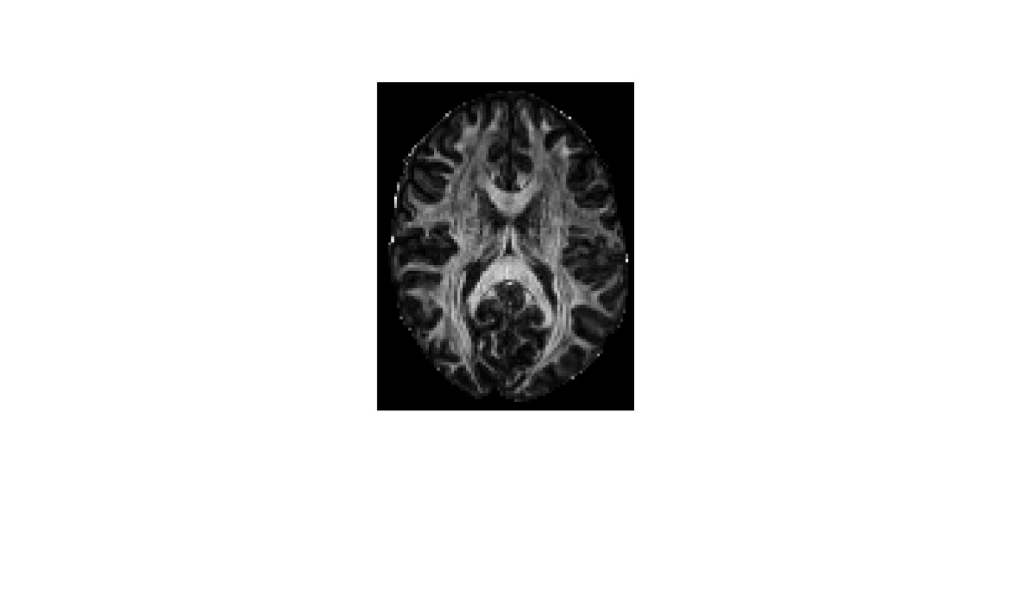To determine the magnitude of the diffusion at each voxel, we find the mean diffusivity (mean of all three eigenvalues) and produce the greyscale image below.

**Fractional anisotropy**

To determine the fractional anisotropy, (a measure of how the eigenvalues differ), we use the given formula (Elster 2009)

Map of the Fractional Anistropy
“For perfect isotropic diffusion . “Brighter areas are more anisotropic than darker areas” – elster, 2009.

Thus, from our image, we can see the very outside of the brain, and the x-shape in the inside, are much brighter and thus more anisotropic.

**Principal diffusion direction**

To determine the principal diffusion direction (the direction of strongest diffusion), we observe the eigenvector  associated with the largest eigenvalue , then use Matlab to produce an image with which it can be visualised.

We use coordinates of (the Eigenvector associated with our largest Eigenvalue) to determine the red, green, and blue pixel intensities, and scale by FA to control brightness.

Thus each voxel is assigned a colour based on both the anisotropy and drection

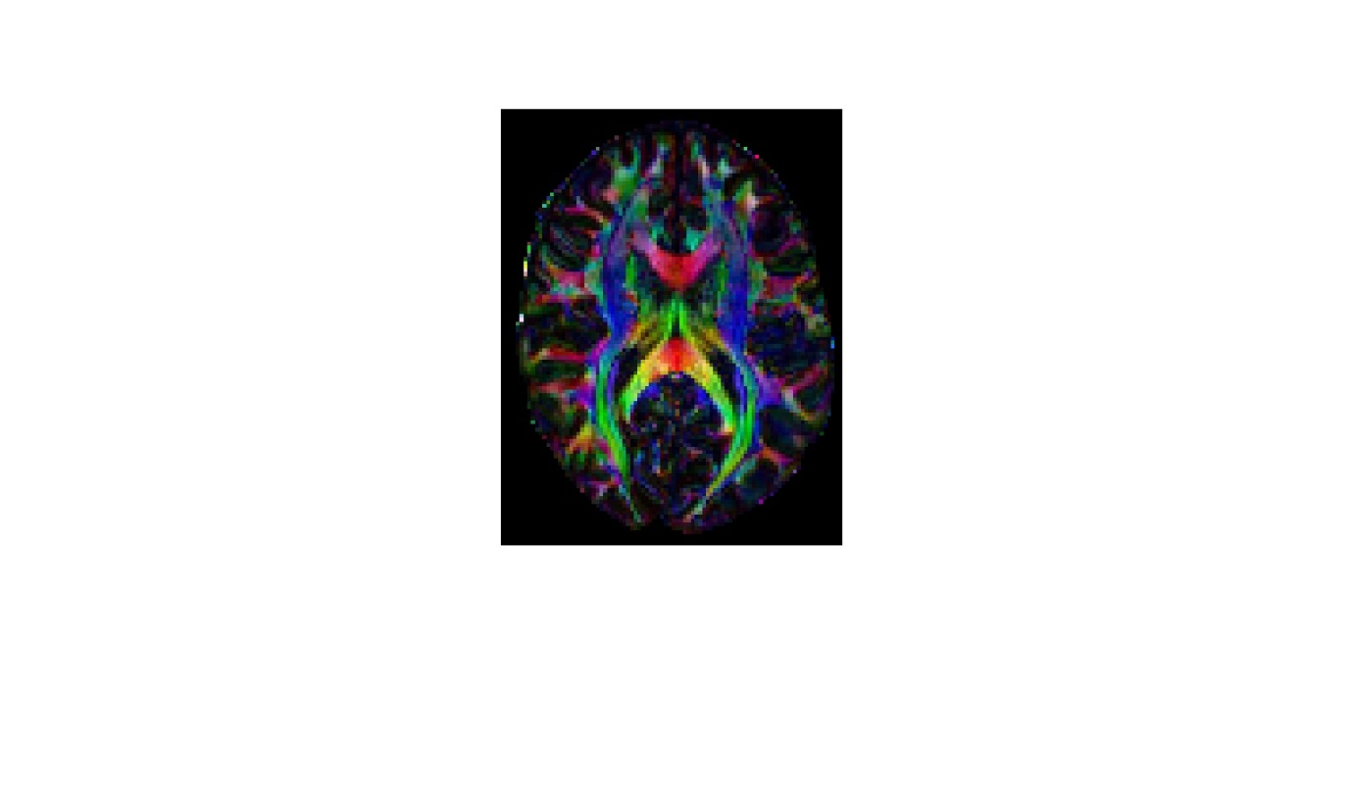

**Reference list**

Elster, AD 2009, DTI, Questions and Answers ​in MRI, viewed 15 May 2024, <https://mriquestions.com/dti-tensor-imaging.html>.

Jiang, H, C.M, P, Kim, J, Pearlson, GD & Mori, S 2005, ‘DtiStudio: Resource program for diffusion tensor computation and fiber bundle tracking’, *Computer Methods and Programs in Biomedicine 81* , vol. 81, no. 2, pp. 106–116, viewed 10 May 2023, <http://individual.utoronto.ca/ktaylor/DTIstudio_mori2006.pdf>.

Moroney, T 2024, *MXB201 Project Description*, *QUT Canvas*, viewed 1 May 2024, <https://canvas.qut.edu.au/courses/17944/assignments/164926>.